UNIT II(ECM)
DIGITAL INSTRUMENTS
2.1Ramp-type DVM:
Its Operating principle is based on the measurement of the time it takes for a linear ramp voltage to rise from 0 V to the level of the input voltage, or to decrease from the level of the input voltage to zero. This time interval is measured with an electronic time-interval counter, and the count is displayed as a number of digits on electronic indicating tubes.
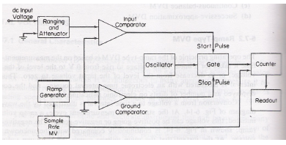
Fig.2.1Block diagram of a ramp type digital voltmeter
The working principle i.e., the Conversion from a voltage to a time interval is illustrated by the waveform in Fig. 2.2
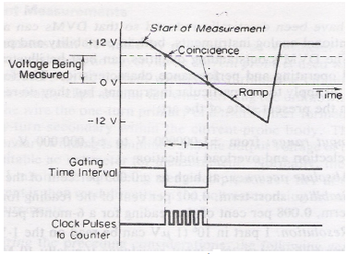
Fig.2.2. Ramp type DVM Waveform
At the start of the measurement cycle, a ramp voltage is initiated; this voltage can be positive-going or negative-going. The negative-going ramp, (see Fig. 2.2) is continuously compared with the unknown input voltage. At the instant that the ramp voltage equals the unknown voltage, a coincidence circuit, or comparator, generates a pulse which opens a gate. The ramp voltage continues to decrease with time until it finally reaches 0 V (or ground potential) and a second comparator generates an output pulse which closes the gate. An oscillator generates clock pulses which are allowed to pass through the gate to a number of decade counting units (DCUs) which totalize the number of pulses passed through the gate. The decimal number, displayed by the indicator tubes associated with the DCUs, is a measure of the magnitude of the input voltage. The sample-rate multivibrator determines the rate at which the measurement cycles are initiated. The oscillation of this multivibrator can usually be adjusted by a front-panel control, marked rate , from a few cycles per second to as high 1,000 or more. The sample-rate circuit provides an initiating pulse for the ramp generator to start its next ramp voltage. At the same time, a reset pulse is generated which returns all the DCUs to their 0 state, removing the display momentarily from the indicator tubes.
2.2DUAL SLOPE INTEGRATING TYPE DVM
This is the most popular method of analog to digital conversion. In the ramp techniques, the noise can cause large errors but in dual slope method the noise is averaged out by the positive and negative ramps using the process of integration. The basic principle of this method is that the input signal is integrated for a fixed interval of time. And then the same integrator is used to integrate the reference voltage with reverse slope. Hence the name given to the technique is dual slope integration technique. The block diagram of dual slope integrating type DVM is shown in the Fig. It consists of five blocks, an op-amp used as an integrator, a zero comparator, clock pulse generator, a set of decimal counters and a block of control logic.
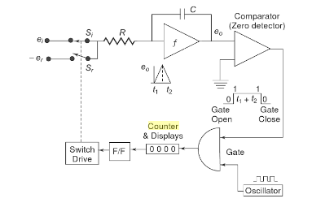.
Fig.2.3.Block diagram of Dual Slope Integrating type DVM
When the switch S₁ is in position 1, the capacitor C starts charging from zero level. The rate of charging is proportional to the input voltage level. The output of the op-amp is given by,

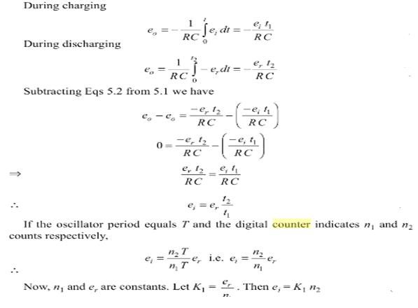
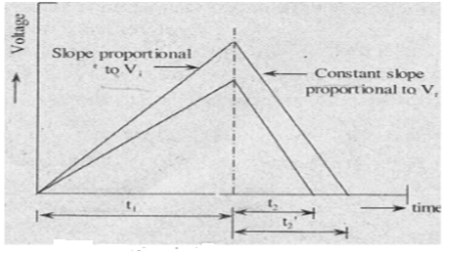
Fig.2.4.Basic Principle
Thus the input voltage is dependent on the time periods t1and t2 and not on the values of R and C. This basic principle of this method is shown in the Fig. At the start of the measurement, the counter is reset to zero. The output of the flip-flop is also zero. This is given to the control logic. This control sends a signal so as to close an electronic switch to position 1 and integration of the input voltage starts. It continues till the time period t. As the output of the integrator changes from its zero value, the zero comparator output changes its state. This provides a signal to control logic which in turn opens the gate and the counting of the clock pulses starts. The counter counts the pulses and when it reaches to 9999, it generates a carry pulse and all digits go to zero. The flip flop output gets activated to the logic level T. This activates the control logic. This sends a signal which changes the switch position from 1 to 2 Thus ei gets connected to op-amp. As er polarity is opposite, the capacitor starts discharging. The integrator output will have constant negative slope as shown in the Fig. 2.3. The output decreases linearly and after the interval t2, attains zero value, when the capacitor C gets fully discharged.
2.3.SUCCESSIVE APPROXIMATION TYPE DVM:
2.3.1Principle: The principle of successive approximation can be easily understood using a simple example: the determination of the weight of an object. By using a balance and placing the object on one side and an approximate weight on the other side, the weight of the object is determined. If the weight placed is more than the unknown weight, the weight we removed and another weight of smaller value is placed and again the measurement is performed. Now if it is found that the weight placed is less than that of the object, another weight of smaller value is added to the weight already present and the measurement is performed. If it is found to be greater than the unknown weight, the added weight is removed and another weight of smaller value is added. In the same way the successive approximation DVM works on the same principle.
Its basic block diagram shown in Fig.2.5.when the start pulse signal activates the output of SAR is 00000000 V_{out} of the D/A converter is zero(0).Here the reference voltage V_{ref} =5v and voltage to be measured V_{in} =1v.During first clock pulse the control circuit sets D₇ to 1 and V_{out}=2.5v.For the next clock pulse D₆ is set, the previous D₇ value (set or reset) depends on V_{in} and V_{out} relation. Here V_{in} < V_{out} then D₇ value reset to 0.This logic continues up to D₀ as shown in table, finally SAR register will display the input value as 0.99785.

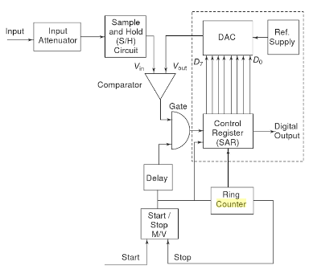
Fig.2.5.Successive approximation DVM

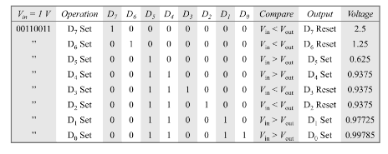
Table2.1.Sucessive approximation type DVM table
2.4.Digital multimeter:
The digital multimeter is an instrument which is capable of measuring a.c. voltages, d.c. voltages, a.c. and d.c. currents and resistances over several ranges. The basic circuit of a digital multimeter is always a d.c. voltmeter as shown in the Fig2.6
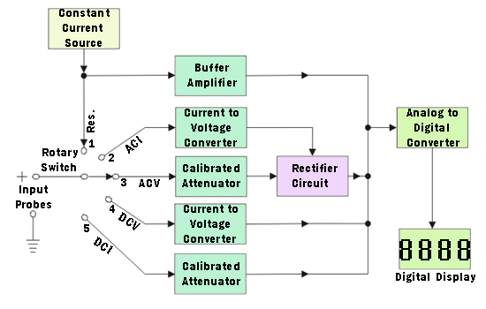
Fig.2.6.Digital Multimeter
The current is converted to voltage by passing it through low shunt resistance. The a.c. quantities are converted to d.c. by employing various rectifier and filtering circuits. While for the resistance measurements the meter consists of a precision low current source that is applied across the unknown resistance while gives d.c. voltage. All the quantities are digitized using analog to digital converter and displayed in the digital form on the display. The basic building blocks of digital multimeter are several AID converters, counting circuitry and an attenuation circuit. Generally dual slope integration type ADC is preferred in the multimeters. The single attenuator circuit is used for both a.c. and d.c. measurements in many commercial multimeters. The block diagram of a digital multimeter is shown in the Fig.2.6.

2.5.Digital Tachometer:
The digital tachometer is used to measure speed of a motor. The technique used for the measurement of a speed of a rotating shaft of a running motor is same as that used in the conventional frequency counter. But in conventional frequency counter, the gate pulses are obtained in accordance with the Schmitt trigger output while in the digital tachometer the gate period is selected in accordance with the r.p.m calibration.

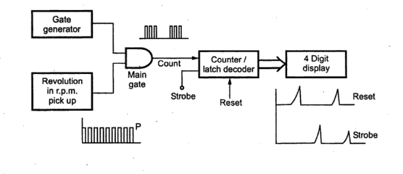
Fig.2.7.Digital Tachometer
A typical schematic diagram of digital tachometer is shown in Fig.2.7
Consider that the revolution per minute of a shaft be R. Assume that the number pulses produced the direct reading is possible in rpm if only the gate period is (60/P) and the pulses counted by the counter are R i.e(R*P*(60/P))/60=R.

2.6.Digital phase meter:
The above circuit technique to measure the phase difference between the signals employing to flip flops this signals to be tested must be of the same frequency first ,the signal must be sacked square waveform without any changing with their position by use of zero crossing detector. The block diagram of digital phase meter as shown in fig.2.8.The block diagram consists of two pairs of pre-amplifiers, zero crossing detector, J-K Flip Flop and control gate two signals having phase V1 and V2respectively are applied as input to the pre- amplifier with amplitude and frequency of the two inputs is the same but their phases are difference.
As the V1 input signal increasing in the positive half cycle, the zero crossing detector changes its state when the input cross zero giving a high level at the output. This cause the J-K flipflop1 to be said i.e, the output (Q) of J-K flipflop1goes to high .This high output from the J-K flipflop1 enable the AND gate ,and pulse from the clock are fed directly to the counter. The counter start counting those pulses also this output level of J-K flipflop1 is applied to clear input of J-K flipflop2 which makes the output of J-K flipflop2 goes to zero.
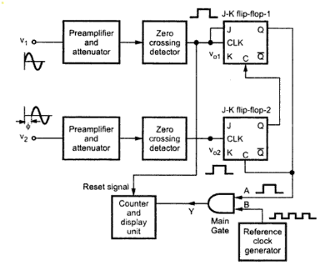
Fig.2.8.Digital Phase Meter
Now as the input V1 which has a phase different w.r.t V2 ,cross zero in positive half cycle, the zero crossing detector is activated, causes its output to go high. This high input in turn on J-K flip flop 2, makes its output go to high. The output of J-K flip-flop 2 is disconnected to the clear input of the J-K flipflop1,force the J-K flipflop1 to reset hence the output of J-K flipflop1 goes to zero. The AND gate has disabled and the counter stops counting.
The number of pulses counted while enabling and disabling the AND gate is in direct proportion to phase difference. Hence the display unit gives a direct read out of the phase difference between the two inputs having the same frequency.

2.7.Stair case ramp type DVM:
2.7.1. Principle: The input signal is compared with an internally generated voltage which is increased in steps starting from zero. The number of steps needed to reach the full compensation is counted. The basic principle is that the input signal Vi is compared with an internal stair case voltage, Vi generated by a series circuit consisting of a pulse generator, a counter counting the pulses and a DAC converter output into a DC signal as soon as Vc =Vi , the input comparator closes the gate between the clock and counter, the counter stops and displays the input voltage as shown in Fig.2.9

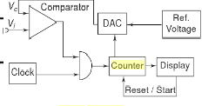
Fig.2.9.Block diagram of stair case Ramp type
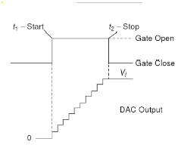
Fig.2.10.Staircase Waveform
2.7.2. Operation of the circuit: The clock generates pulses continuously. At the start of a measurement, the counter is reset to 0 at a time t1 so that the output of a DAC is also 0.If vi is not equal to 0, the input comparator applies an output voltage that opens the gate so that clock pulses are passed on to the counter through the gate. The counter starts counting and the DAC starts to produce the output voltage increasing by one small step at each count of the counter the result is a stair case voltage applied to the second input of the comparator as shown in Fig.2.10 this process continues until the stair case voltage is equal to or slightly greater than the input voltage Vi at that instant t2,the output voltage of the input comparator changes state or polarity, so that the gate closes and counter is stopped. The display unit shows the result of the count.
2.8Universal counter:
All measurements of time period and frequency by various circuits can be assembled together to form one complete block, called universal counter timer. The universal counter uses logic gates which are selected and controlled by a single front panel switch known as function switch. A simplified block diagram is shown in Fig.2.11
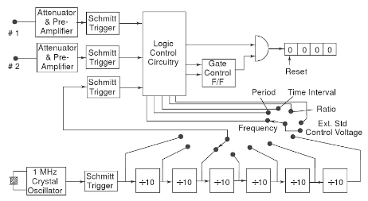
Fig.2.11.Block diagram of Universal counter-timer
2.9.Auto Ranging 3,31/2,33/4 Digit display:
The number of digit positions used in a digital meter determines the resolution. Hence a 3 digit display on a DVM for 0-1 range will indicate values from 0-999 mV with a a smallest increment of 1mV.
Normally, a fourth digit capable of indicating 0 or 1 (hence called half digit)is placed to the left. This permits the digital meter to read vales above 999 up to 1999,to give overlap between ranges for convenience, a process called over ranging. This type of display is called a 31/2 digit display shown in fig.2.12
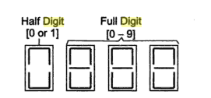
Fig.2.12. 31/2 Digit Display

